# WebDAV Service Setup Using Linux and Apache

## Introduction

This document is simple example that will allow the reader to implement a WebDAV service using the Linux command line and the Apache 2 HTTP server. Once the WebDAV service is implemented it will allow access to files over HTTP using a WebDAV client.

## Method

1. Open a Linux terminal as a user that has access privileges to use ‘sudo’ commands. Check with your systems admin that you are on the ‘sudoers’ list.
2. Install Apache 2 HTTP server using the command:

sudo apt-get install apache2

You may need to use this command first:

sudo apt-get update

1. Enable the WebDAV modules using the command:

sudo a2enmod dav_fs

1. Restart the Apache 2 server by using the command:

sudo /etc/init.d/apache2 restart

1. Create a new directory for WebDAV using the command:

sudo mkdir /var/www/WebDAV/

1. Create another subdirectory to store files:

sudo mkdir /var/www/WebDAV/files

1. Set the ownership of the WebDAV folder to www-data (the user ID for Apache 2) and the group to that of your username. This is done using the following command:

sudo chown -R www-data:user /var/www/WebDAV

1. Change the file permission of the folder to enable reading and writing and execution of files. This is done by using the following command:

sudo chmod 775 -R /var/www/WebDAV

1. Install a command line text editor to create, view and edit files. For this example we use Nano, many other text editors are available, but this is one of the simplest to use. Type the following command to install:

sudo apt-get install nano

1. Create or edit a virtual host file (vhost). This file is used for the URL through which WebDAV will be accessed. Apache has a default vhost file which can be edited, or a new one can be created. The open and edit the default vhost file use the following command:

sudo nano /etc/apache2/sites-available/default

The following line must be added to the file:

Alias /webdav /var/www/WebDAV/files

This will allow the WebDAV folder to be accessed using a URL like this:

http://myhost.mydomain.org/webdav

The vhost file should resemble something like this:

**<**VirtualHost **\*80>**

#

# UseCanonicalName off

# ServerName webdav.mydomain.org

ServerName myhost**.**mydomain**.**org

ServerAlias 192.168.0.155 webdav**.**mydomain**.**org

#

ServerAdmin root@localhost

DocumentRoot **/**var**/**www**/**

#

Alias **/**webdav **/**var**/**www**/**WebDAV**/**files

#

**<**Directory **/**var**/**www**/**WebDAV**/>**

Options Indexes MultiViews

AllowOverride None

Order allow**,**deny

allow from all

**</**Directory**>**

**</**VirtualHost**>**

In this example the WebDAV service can be accessed from within the local network by using the URL’s:

http://192.168.0.155/webdav or http://localhost/webdav

1. To enable the virtual host file use the following link command:

sudo ln –s /etc/apache2/sites-available/default /etc/apache2/sites-enabled

1. For the changes to take effect, restart the Apache server using this command:

sudo /etc/init.d/apache2 restart

When restarted, test that the folder is reachable by typing the URL into a web browser, use:

**http://192.168.0.155/webdav** or **http://localhost/webdav**

1. To ensure secure access to the WebDAV folder we must create usernames and passwords. For this example we will use a method known as Digest Authorization, which will produce encrypted passwords. First the HTTP Digest Authentication module is enabled using this command:

sudo a2enmod auth_digest

Then create a digest authorization password file with a new user, this example calls the new user ‘testuser’.

sudo htdigest –c /var/www/WebDAV/digestpasswd.dav webdavdigest testuser

The command line will prompt you to type a password for this user. To add additional users, use the same command without the –c switch which was used to create the file, as shown:

sudo htdigest /var/www/WebDAV/digestpasswd.dav webdavdigest testuser2

Some Windows clients append the URL of the WebDAV folder to the username. So to allow for this a Windows username and password can be created using this command:

sudo htdigest /var/www/WebDAV/digestpasswd.dav webdavdigest myhost.mydomain.org\\windowsuser

1. Change permissions for the digest password file so that only the users www-data (the owner) and user (or root) can access it:

sudo chown www-data:user /var/www/WebDAV/digestpasswd.dav

sudo chmod 660 /var/www/WebDAV/digestpasswd.dav

1. Edit the virtual host file (vhost) to enable use of the password file:

sudo kate /etc/apache2/sites-available/default

Add the following lines to the file:

#

**<**Location **/**webdav**>**

DAV On

AuthType Digest

AuthName "webdavdigest"

AuthUserFile **/**var**/**www**/**WebDAV**/**digestpasswd**.**dav

Require valid-user

**</**Location**>**

1. Enable WebDAV lock to prevent multiple users from changing files at the same time. Create a global Apache 2 configuration file using Nano:

sudo nano /etc/apache2/conf.d/webdav

Add this line:

DavLockDB /var/lock/apache2/DAVLock

Edit the dav_fs configuration file to declare the correct path of the lock file by accessing it like this:

sudo nano /etc/apache2/mods-available/dav_fs.conf

You need to simply update the line in the file to match the previous file which was this:

DavLockDB /var/lock/apache2/DAVLock

Enable the Apache 2 dav_lock module by using the following command:

sudo a2enmod dav_lock

Restart Apache:

sudo /etc/init.d/apache2 restart

1. To test the WebDAV service is working as it should, install the command line WebDAV interface Cadaver:

sudo apt-get install cadaver

To use Cadaver to access the WebDAV service type:

cadaver http://localhost/webdav

The command line should ask for a username and password

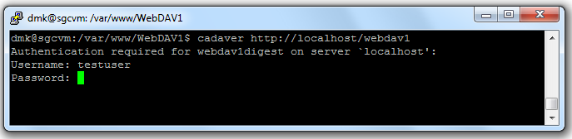

Once logged in type help to view all available commands.

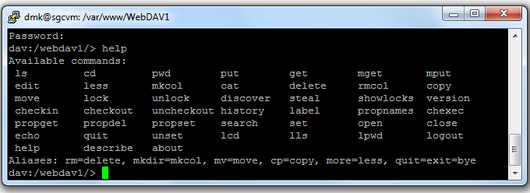

## Reference

This document has been adapted from an article in the Ubuntu Guide Wiki. The original article can be found at:

<http://ubuntuguide.org/wiki/WebDAV>